Mr. Sabado, Pre-Algebra Tuesday, October 29, 2013

Homework

Due Today:
-Page 106: 11-31 odd
Page 113: 1-25 odd

Due 10/31:
-Page 117: 1-40, 42-53

Chapter 2 Test on Thursday!!!

Agenda

- Warm-Up

- Homework Check

- Review: Chapter 2 Review Stations

- Class Work

- Return Graded Work

Warm-Up

Solve
- 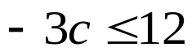
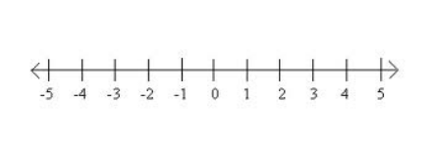

2) 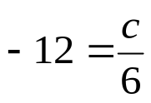


whs.saba.do

“It is never too late to be what you might have been.”
- G. Eliot

